

**Object Oriented Programming Lab**

**FACULTY: AVITA KATAL**

**SANJLI VERMA**

**CSE (SPEC. GAMING AND GRAPHICS)**

**500086136**

**EXPERIMENT 11Top of Form**

1.Create a database table to store the records of employee in a company. Use getConnection function to connect the database. The statement object uses executeUpdate function to create a table.

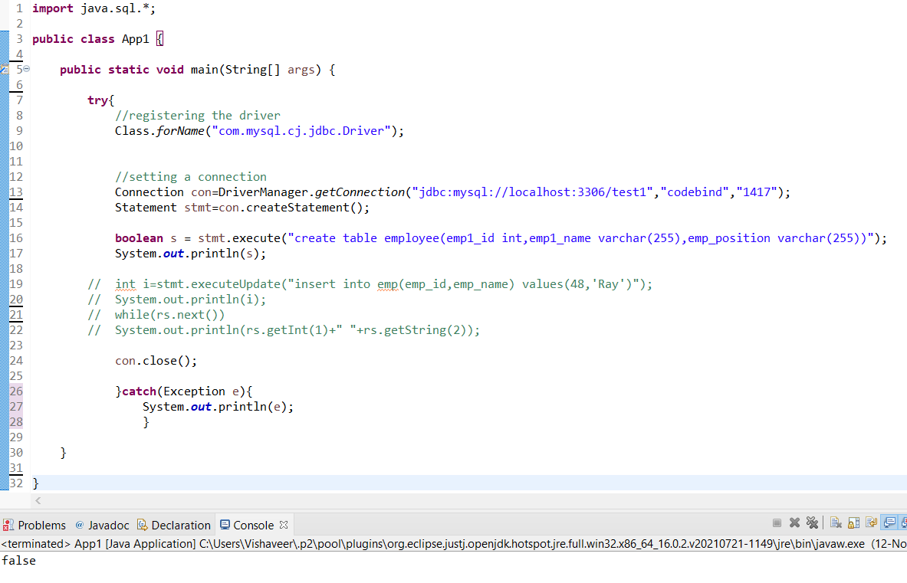

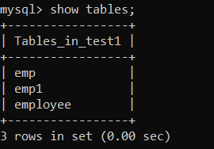

2.Create a database of employee of company in mysql and then use java program to accessthe database for inserting information of employees in database. The SQLstatement can be used to view the details of the data of employees in the database.

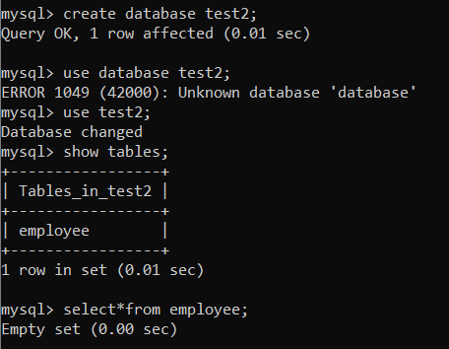

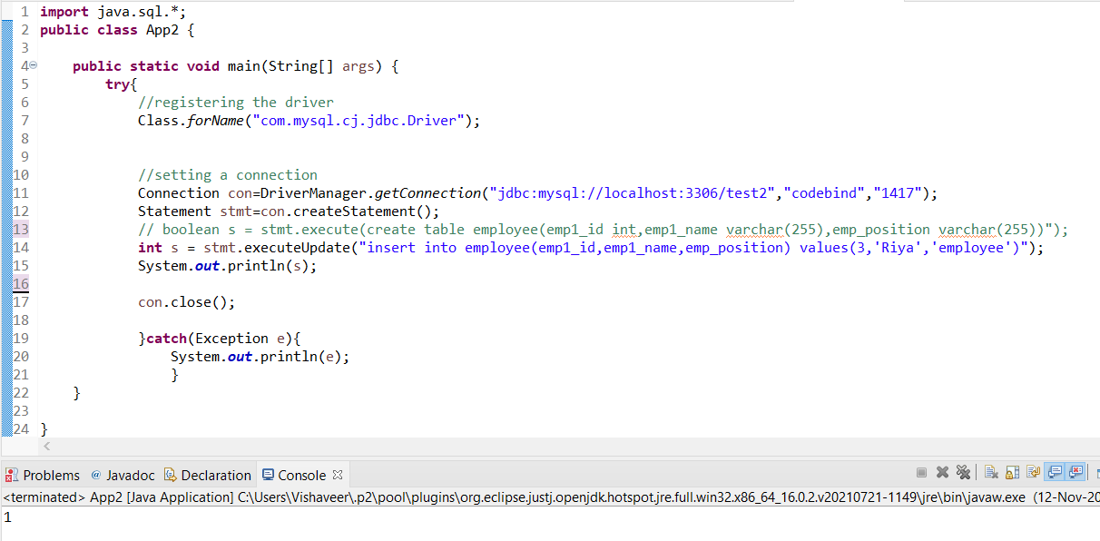

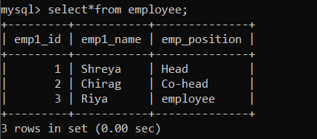

3.Create a table Meeting having columns (NameOfParticipant, MeetingID, ScheduledTime,Email, Mobile), Populate with random data and perform following operations. READ COMPLETE QUESTION TO POPULATE DATABASE.

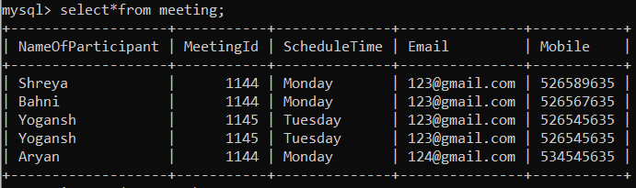

1. Display the names on the console, preceded by the message, “Names of participants in meeting 1144”.

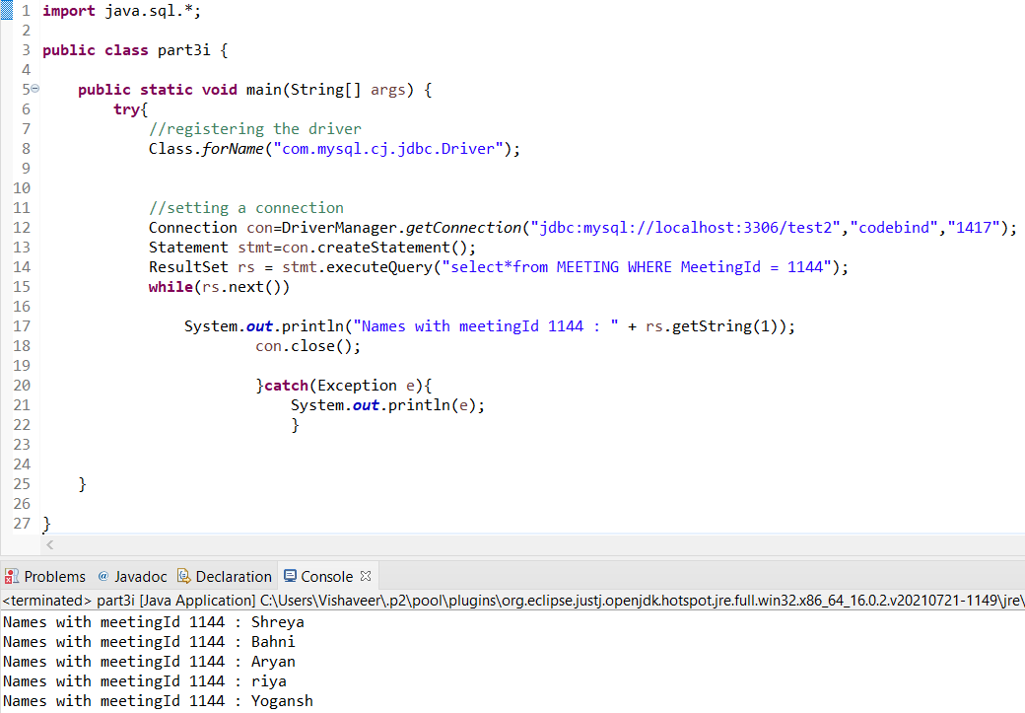

1. Don’t specify the participant ID - let the ID be determined by the database. Determine the ID that was assigned to the new participant and display it on the console (the statement that displays the ID should display the name of the new participant as well).

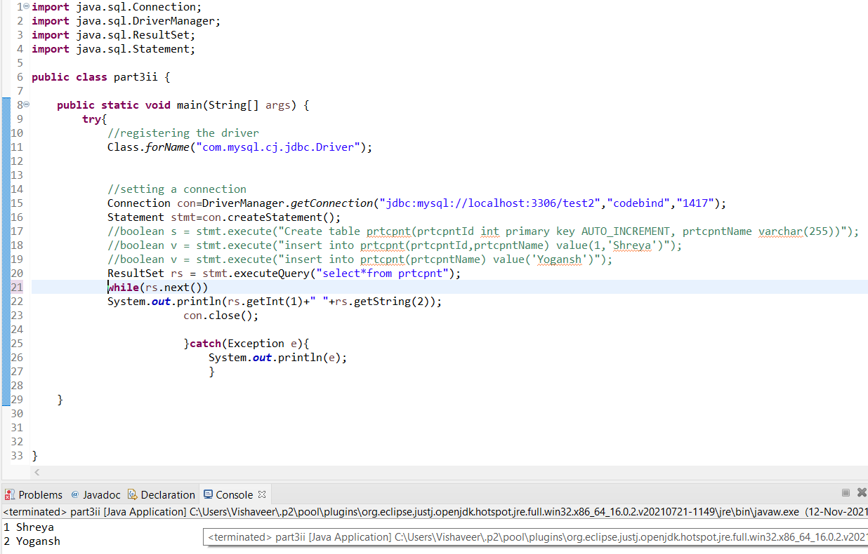

1. Display a message on the console that gives both the meeting name and the number of participants.

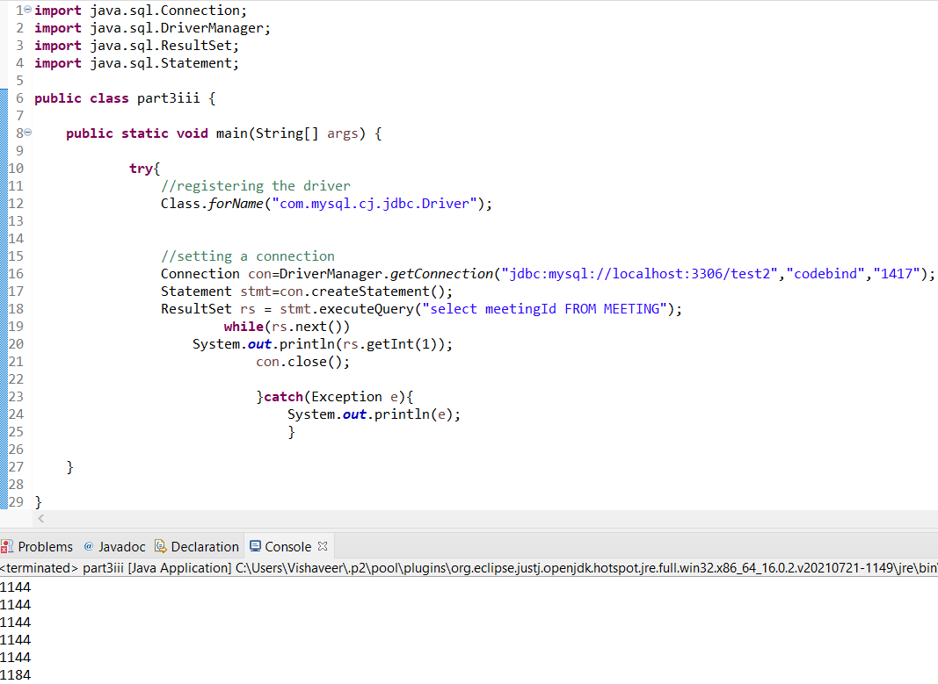

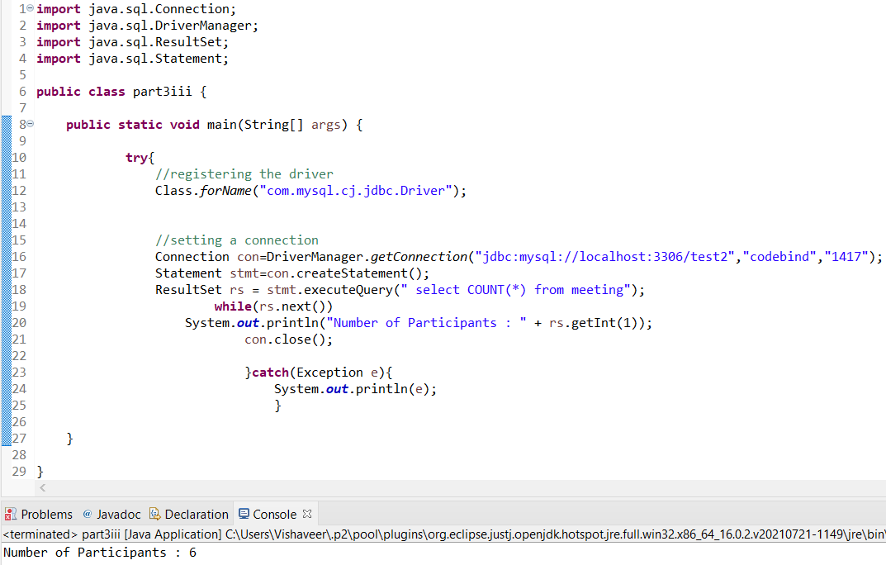

1. Display the names, preceded by the message, “Participants attending Tuesday meetings”.

